**Digital Ecosystem Documentation**

There are three basic tasks that are performed in Node- Red

**MQTT**

1. Converting the values into Integer.
2. Rearranging the real time values into a JSON form.
3. Save the data to Influx DB for historical use.

**OPC UA**

1.Time Calculation - Total time the LED’s in on state.

a)FlowChart

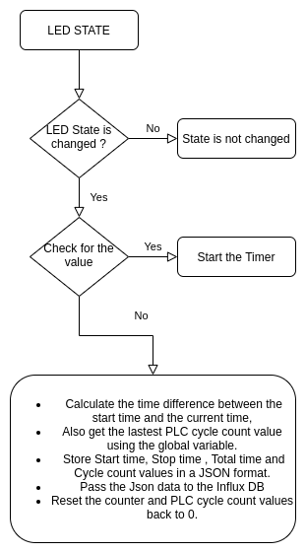

b) Node Red Flow

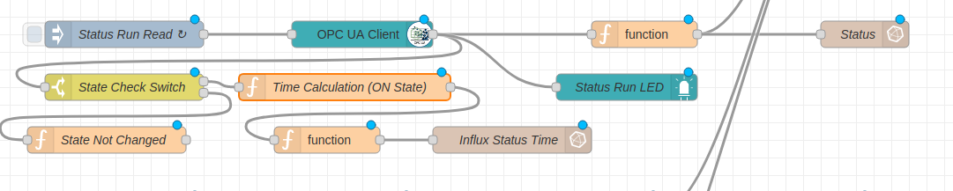

In the above example, we will be reading the Status of the **Status Run switch** using the **OPC UA Client node** and then pass it to the **State Check switch**.  
OPC UA Client switch is also connected to the **Status Run LED** as it turns on/off the LED based on the value read via OPCUA Client.

In the **State Check Switch** , we check if the state of the OPCUA Client is changed or not as show in below diagram. If it is changed, then we will proceed to the Time Calculation part. If not we display a State not changed message.

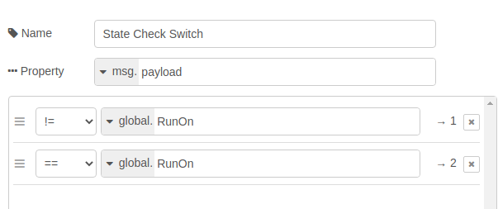

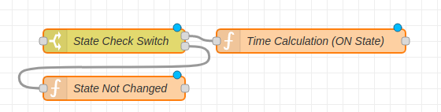  
Time calculation part is explained in the above flow chart and the code for the same is as shown below.

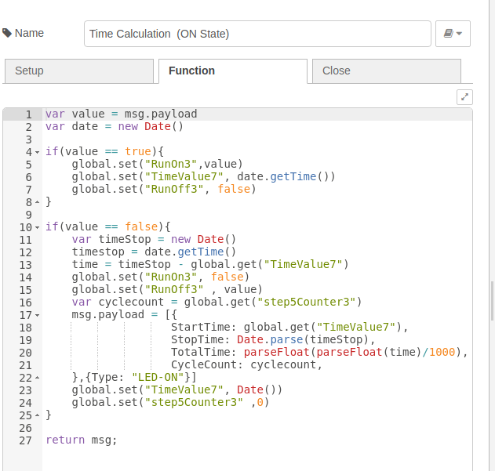

All the data is accordingly stored in the real time database InfluxDB.

2. Number of cycles completed by the PLC when in ON state.

We calculate this using a global variable and this Global variable will be incremented by 1 when the OPC UA Client of Step 5 counter represents true. And when there is change of state in the LED’s we save the Global Variable value to the Influx DB and then reset it to 0.

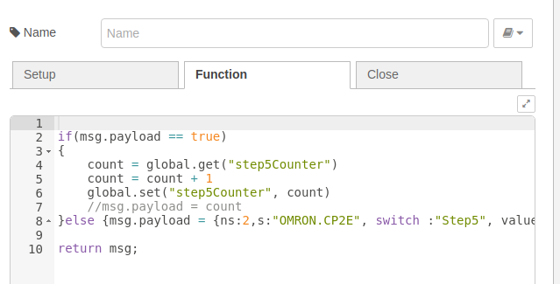

3. Record the state of all switches/LEDs every second for Historical data analysis.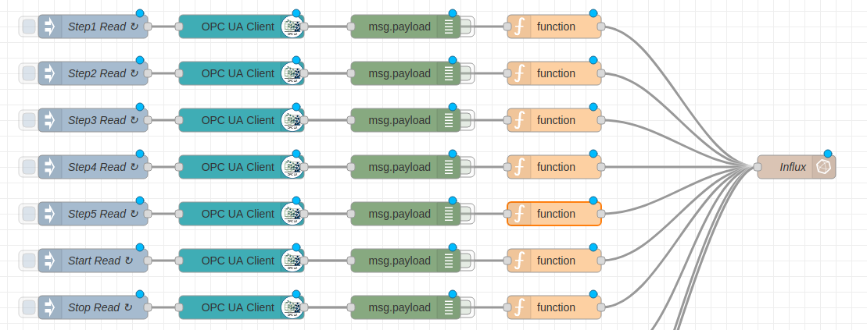

In the above diagram , we are reading the values of all switches using the OPC UA client node and then store the same in the influxdb every second for the tracking purpose.

4. Pass all relevant information to Influxdb.

The Influx DB measurements are as shown below

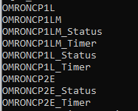

_Status - Help us to know the status of all switches and it will be stored every second.

_Timer - This is to save the number of time the LED’s were on and also to calculate the number of cycle completed by the PLC.

We make use of this historical data in order to visualize the same in Grafana.